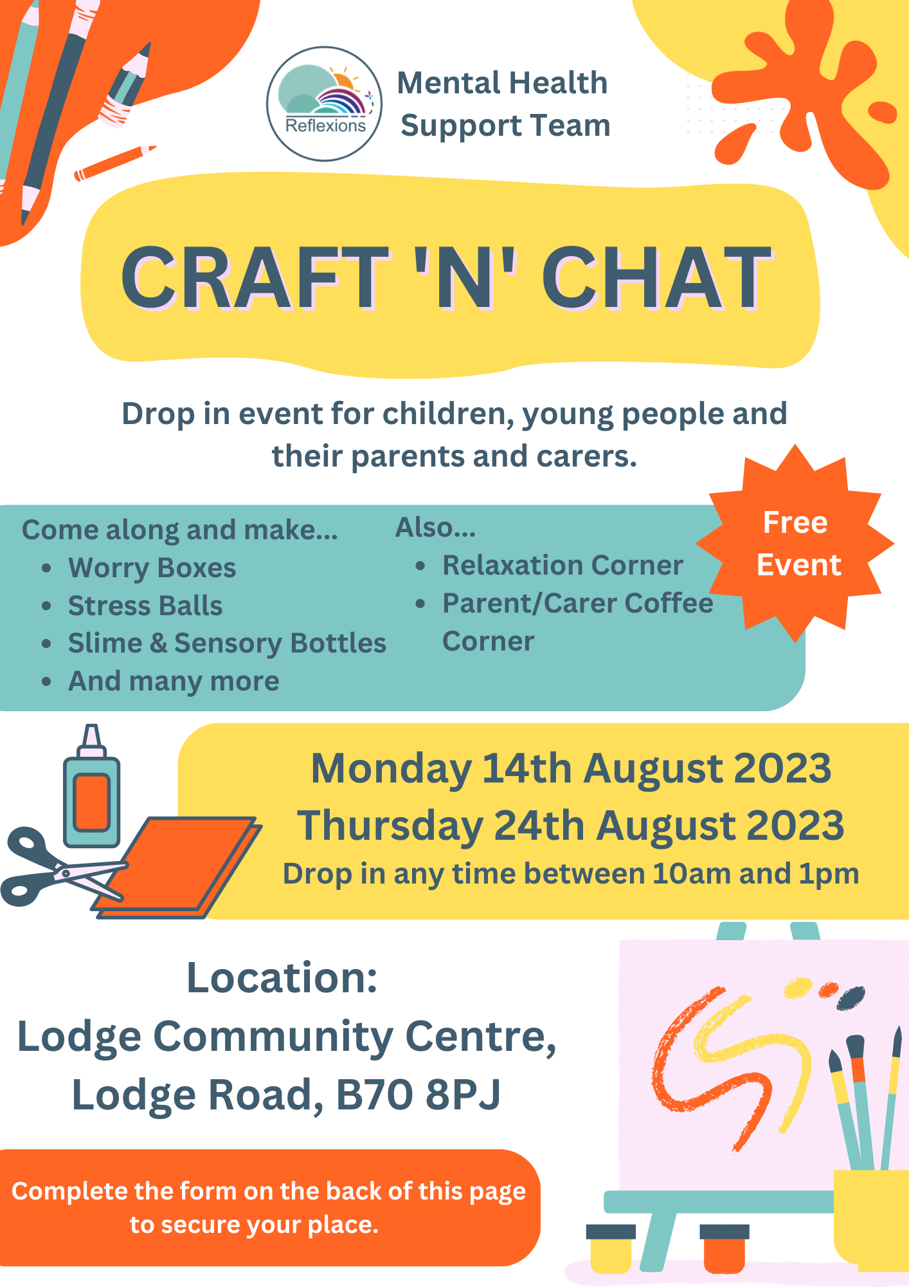
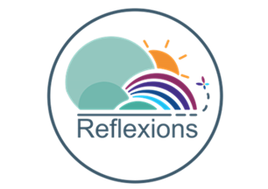

If your child would like to attend the Craft ‘n’ Chat event please complete the below form by Monday 7th August 2023. Please send completed forms via email to bchft.reflexions@nhs.net.
Child/Young Person’s Details:
Name: | Date of birth: |  | Age:
Address:

Postcode:

Gender: |  | Ethnicity:
School Name:

Any known allergies? ☐ Yes ☐ No

If yes, please provide details:

Does the child/young person have any Special Educational Needs? Yes ☐ No ☐
If yes, please provide details:

Parent(s)/Guardian(s) details:
Name(s):

Contact number(s):

Email address(es):

Consent:
As parent/guardian I consent to my child attending the event: ☐

During the event, Reflexions will take photographs for social media purposes, do you consent for your child’s photograph to be taken? Yes ☐ No ☐

Do you consent to your child being administered First Aid if required? Yes ☐ No ☐

Please state which date(s) you will be attending the event:

